LK-A/B/C Series Specifications

1.0 Scope

1.1 This specification in combination with pump data sheets identifies the minimum requirements for diaphragm metering pumps.

2.0 Definitions

2.1 Mechanically Actuated Diaphragm Pump - a positive displacement diaphragm-metering pump in which there is a direct coupling mechanism between the diaphragm and the motor.

3.0 General

3.1 Output volume shall be adjustable while pump is in operation.

3.2 Weight of pump as installed shall not exceed 350 pounds (including standard TEFC motor).

3.3 Pump shall fit within a rectangular volume 34” long by 14” wide by 34” high.

3.4 Metering accuracy shall be ±2% full scale or better.

3.5 Output linearity shall be ±3% full scale or better.

3.6 Noise level shall not exceed 99dB.

4.0 Drive

4.1 The mechanically actuated diaphragm metering pump mechanism shall be totally enclosed with no exposed moving parts.

4.2 The p ump drive shall utilize a lost motion design. The rotation of the motor shall be reduced by means of a worm and wheel. The rotation shall be converted to a reciprocating motion by means of a dual cam, and a spring back mechanism including the worm wheel, shaft, slider, and spring.

4.3 The pump drive shall be oil-bath lubricated

4.4 The diaphragm shall be mechanically connected to the pump drive. There shall be no hydraulic oil backing of the diaphragm to ensure there is no contamination of the process fluid in the event of a diaphragm failure.

4.5 Pump drive shall be operated by an IEC B5 flange electric motor appropriate to size.

4.6 Metering pump shall be capable of pumping a maximum capacity (GPH) against a maximum pressure (PSI). (Capacity and Max pressure from Table 1)

4.7 Stroke length shall be adjustable from 0% to 100% by means of a micrometer dial.

5.0 Materials of construction

5.1 Pump housing shall be epoxy painted aluminum.
5.2 All exposed fasteners shall be stainless steel.
5.3 Liquid end materials shall be as shown in Table 2.

6.0 Shop tests

6.1 All pumps shall pass manufacturer’s standard performance test.

Table 1 Capacity/Pressure Rating

Model | Capacity ^{Note 1} |  | Max. Pressure |  | Stroke Speed |  | Effective Diaphragm diameter mm | Connection ^{Note 2} | Motor  output  HP (kW) | IEC Motor ⁴  Mount  Frame Size
 | 60 Hz  GPH (LPM) | 50 Hz  GPH (LPM) | PVC  PSI (MPa) | SS  PSI (MPa) | 60 Hz  spm | 50 Hz  spm |  | (NPT)  Flange  ANSI 150lb
LK-A55 | 52.3 (3.3) | 44.4 (2.8) | 145.0 (1.0) |  | 58 | 48 | ø100 | ½” | 0.5 (0.4) | 71 M
LK-A57 | 114.1 (7.2) | 95.1 (6.0) | 101.5 (0.7) |  | 116 | 96
LK-A65 | 171.2 (10.8) | 142.6 (9.0) | 43.5 (0.3) |  | 58 | 48 | ø138 | 1 ½”
LK-B65 | 171.2 (10.8) | 142.6 (9.0) | 72.5 (0.5) | 101.5 (0.7) | 58 | 48 | ø138 | 1 ½” | 1.0 (0.75) | 80 M
LK-B75 | 253.6 (16.0) | 210.8 (13.3) | 72.5 (0.5) |  |  |  | ø150 | 2”
LK-C76 | 380.4 (24.0) | 317.0 (20.0) | 72.5 (0.5) |  | 86 | 72 | ø150 | 2” | 2.0 (1.5) | 90 L
LK-C86 | 634.0 (40.0) | 523.0 (33.0) | 43.5 (0.3) |  |  |  | ø205 | 2 ½”
LK-C87 | 855.9 (54.0) | 713.3 (45.0) |  |  | 116 | 96
Note 1: The capacity is the value when maximum discharge pressure is applied (with pure water at room temperature). The value may be higher than shown in the table if the discharge pressure is lower. Performance may vary and is based on installation conditions and liquid characteristics.
Note 2: VS type connection is different in some models from standard.
Note 3: A base is furnished to all LK-A, LK-B and LK-C models.
Note 4: IEC B5 flange motor mount. Use vertical mount rated, 1800 RPM motor.
Note 5: Coating color : F37-60D (JPMA)

Table 2 Materials of Construction

Material symbol |  | VC | VH | VS4 | VS¹ | S6 | S4
Application |  | Acids | Alkalines |  | Viscosity & Slurry | Solvents
Applicable to |  | A55 to C87 | A55/A57 | A65 to C87 | A55 to C87 | A55/A57 | A65 to C87
Part | Pump head | PVC |  |  |  | 316SS | SCS13
 | Valve ball | CE | HC | 304SS | HC/304SS | HC | 304SS
 | Valve seat | PVC |  |  | 304SS | 316SS | 304SS
 | O ring | FKM | EPDM |  |  | ---
 | Valve gasket | PTFE
 | Diaphragm | PTFE + EPDM

Note 1: VS valve ball material is HC for A55/A57 and 304SS for the B65-C87 models

Typical chemical:
VC: Sulfuric acid, Hydrochloric acid, Sodium hypochlorite
VH, VS4: Caustic soda, Coagulant. Calcium hydroxide (low density)
VS: Calcium hydroxide, High molecular coagulant
S6, S4: Organic solvents
Material symbols
SCS13: Cast Stainless steel equivalent to 304SS
CE: Ceramic
FKM: Fluoroelastomer
EPDM: Ethylene propylene diene monomer
HC: Hastelloy C276
DIMENSIONS

LK-A55, A57, A65, B65, B75, C76, C86, C87
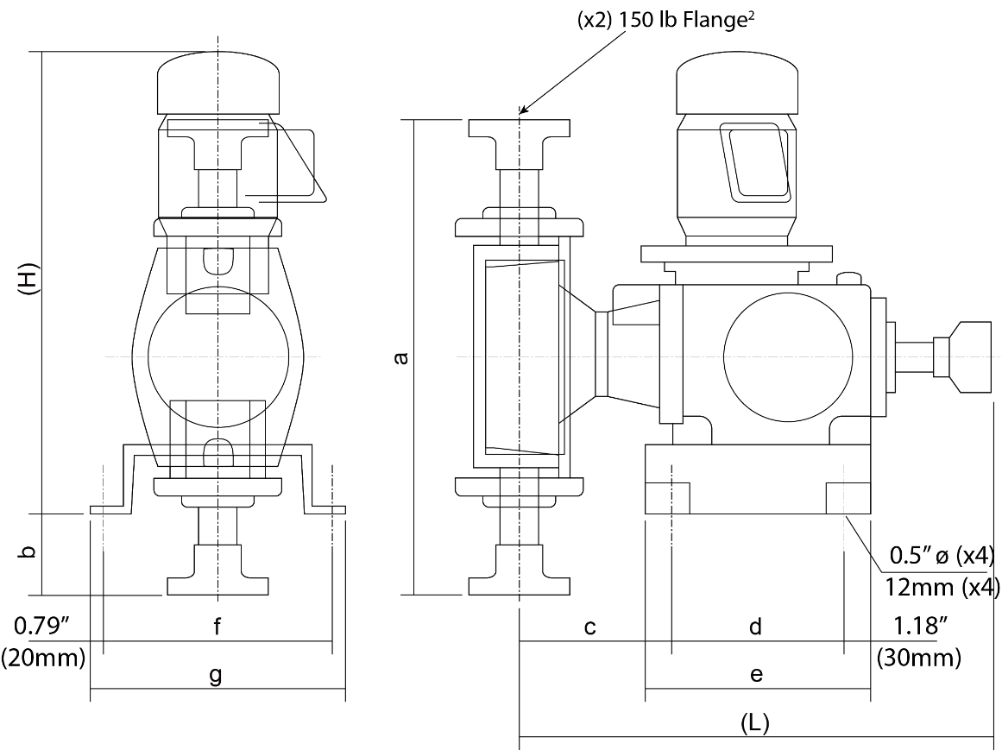
Dimensions
mm | PVC |  |  |  | SS |  |  |  | PVC/SS
 | L | a | b | c | L | a | b | c | H¹ | d | e | f | g
LK-A5 | 476 | 325 | -29 | 111 | 473 | 320 | -32 | 108 | 547 | 180 | 240 | 260 | 300
LK-A6 | 523 | 599 | 108 | 154 | 533 | 431 | 24 | 164 | 547 | 180 | 240 | 260 | 300
LK-B6 | 595 | 599 | 90 | 164 | 605 | 431 | 6 | 174 | 594 | 240 | 300 | 310 | 350
LK-B7 | 599 | 600 | 90 | 167 | 610 | 465 | 23 | 178 | 594 | 240 | 300 | 310 | 350
LK-C7 | 599 | 600 | 90 | 167 | 610 | 465 | 23 | 178 | 601 | 240 | 300 | 310 | 350
LK-C8 | 605 | 647 | 114 | 173 | 609 | 633 | 107 | 177 | 601 | 240 | 300 | 310 | 350

inches | PVC |  |  |  | SS |  |  |  | PVC/SS
 | L | a | b | c | L | a | b | c | H¹ | d | e | f | g
LK-A5 | 18.74 | 12.80 | -1.14 | 4.37 | 18.62 | 12.60 | -1.26 | 4.25 | 21.54 | 7.09 | 9.45 | 10.24 | 11.81
LK-A6 | 20.59 | 23.58 | 4.25 | 6.06 | 20.98 | 16.97 | 0.94 | 6.46 | 21.54 | 7.09 | 9.45 | 10.24 | 11.81
LK-B6 | 23.43 | 23.58 | 3.54 | 6.46 | 23.82 | 16.97 | 0.24 | 6.85 | 23.39 | 9.45 | 11.81 | 12.20 | 13.78
LK-B7 | 23.58 | 23.62 | 3.54 | 6.57 | 24.02 | 18.31 | 0.91 | 7.01 | 23.39 | 9.45 | 11.81 | 12.20 | 13.78
LK-C7 | 23.58 | 23.62 | 3.54 | 6.57 | 24.02 | 18.31 | 0.91 | 7.01 | 23.66 | 9.45 | 11.81 | 12.20 | 13.78
LK-C8 | 23.82 | 25.47 | 4.49 | 6.81 | 23.98 | 24.92 | 4.21 | 6.97 | 23.66 | 9.45 | 11.81 | 12.20 | 13.78
Note 1: Motor height is approximate and will vary by manufacturer and motor type.
Note 2: Flanges conform to ANSI B16.5 150 lb standard. PVC: Flat face flange SS: Raised face flange

